BU Memo Senior Design ENG EC 463

To: Alan Pisano, Osama Alshaykh, Babak Kia

From: John McCullough, Shantanu Bobhate, Brian Tan, Bandhan Zishanuzzaman, Teng Zhang

Team: RightAlert

Date: 2/26/2016

Subject: Right Alert Second Deliverable Test Report

**1.0 Equipment and Setup**

**1.1 Equipment**

The Bike Detection System consists of the Jetson TK1, a power supply circuit, a camera, an alert sign, and finally a website. These components can be seen in the following block diagram :

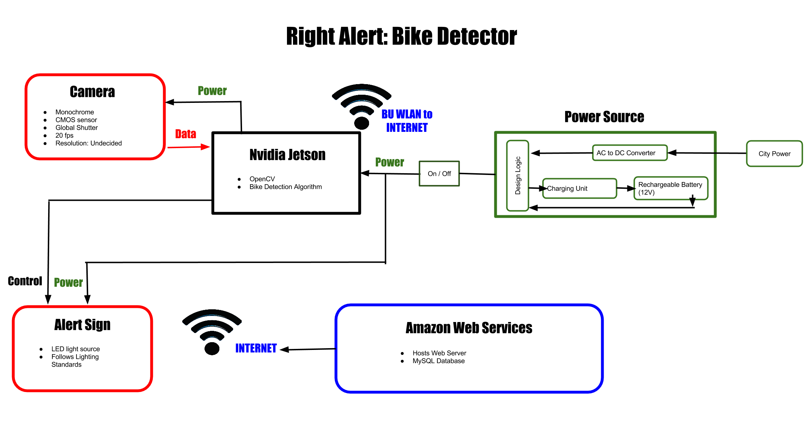

For testing we had either the final components from the block diagram or forms of the components that would resemble those in the final product. Our equipment list was as follows:

1. Jetson TK1

# ELP 1080x960 Hd 2.8-12mm Varifocal Lens USB Webcam

1. Venom 12V 6400 mAH Lipo Battery
2. LED circuit which substitutes for the final alert sign
3. Bike detection algorithm
4. The RightAlert website

The pieces of equipment that could be found directly in the final design are the Jetson TK1, ELP USB webcam, bike detection algorithm, and the RightAlert website. The battery itself will be part of a more complex circuit which includes a solar panel and logic to determine when it is safe for charging. In addition, the LED circuit will not be in the final alerting system. Rather a regulatory bike alerting sign will be in its place.

**1.2 Setup**

For testing, there were two areas required of setup. One being the physical bike detection system being demonstrated during testing and the other being the detection algorithm.

First, we will describe the arrangement of the bike detection system. For the system, we had all the working parts connected to the Jetson TK1. The camera which will be used to survey bikers connected to the Jetson through its USB port. The LED circuit was connected to the board’s GPIO pins. All while this was happening, the board was being powered by the Venom 12V 6400 mAH Lipo Battery through its barrel jack port. In order to observe the algorithm running, the Jetson was connected to a display monitor via HDMI cable.

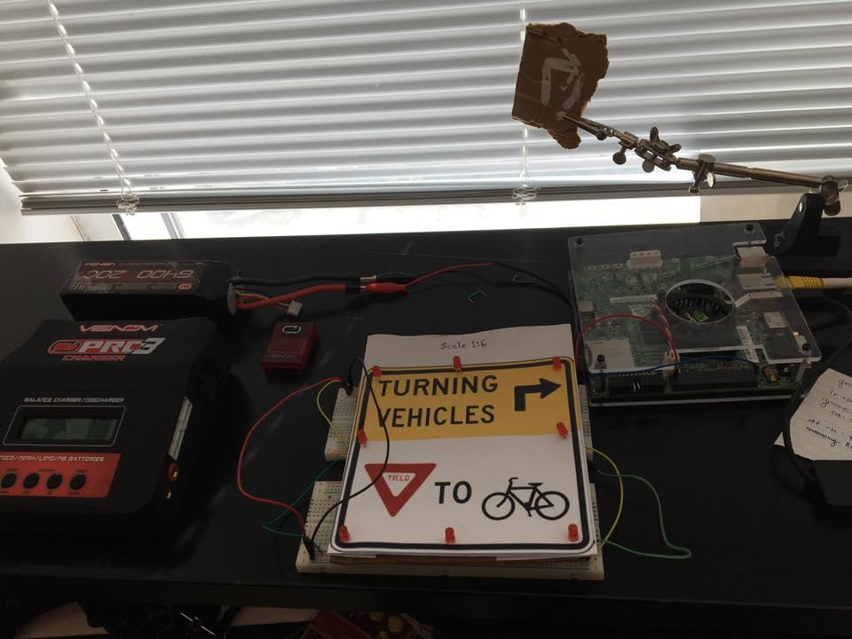

Image of bike detection system setup.

Behind the scenes, the algorithm would require a setup of its own. With the algorithm using a machine learning method to recognize bikes, it needed a large set of positive biker images and a large set of negative biker images. To ensure that the set of training photographs would provide the most effective learning experience, the team had to test the camera for the best mounting position. Testing the mounting position of the camera would provide us with both test pictures as well as a final plan of how to setup the camera when the final system is implemented out on the streets.

To test the camera, the team created a temporary mounting mechanism which would allow for the camera to adjust its angle and height on a pole in between testing sets.

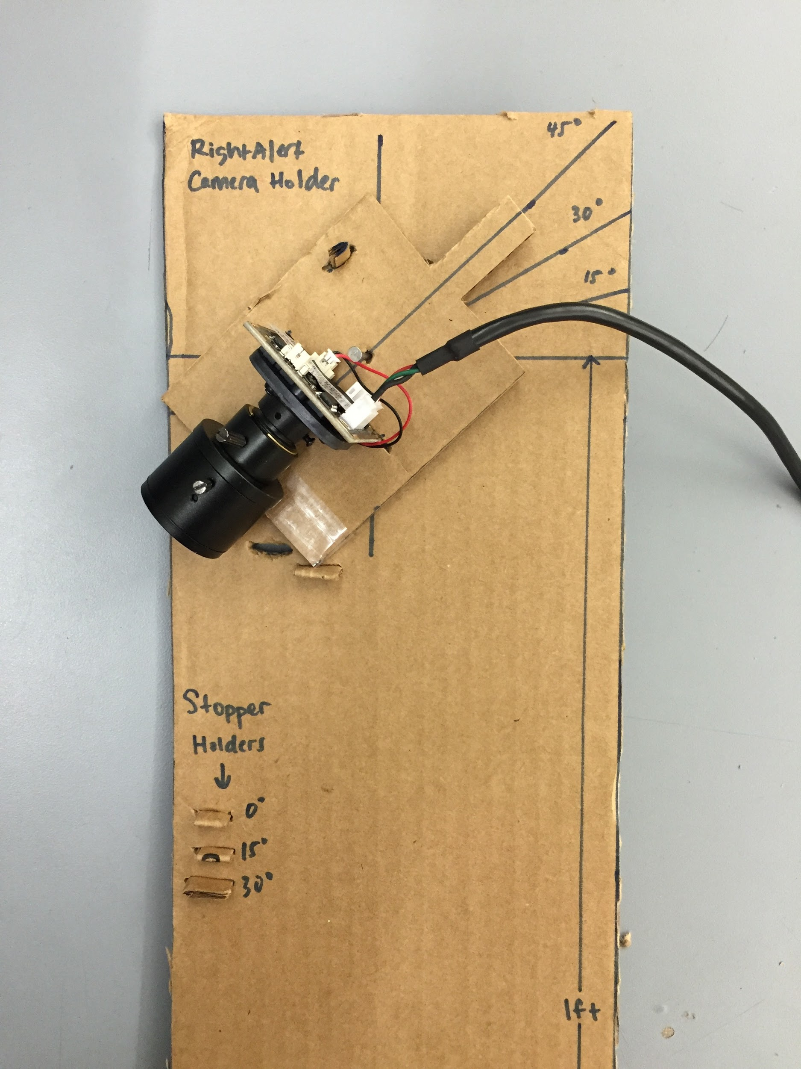 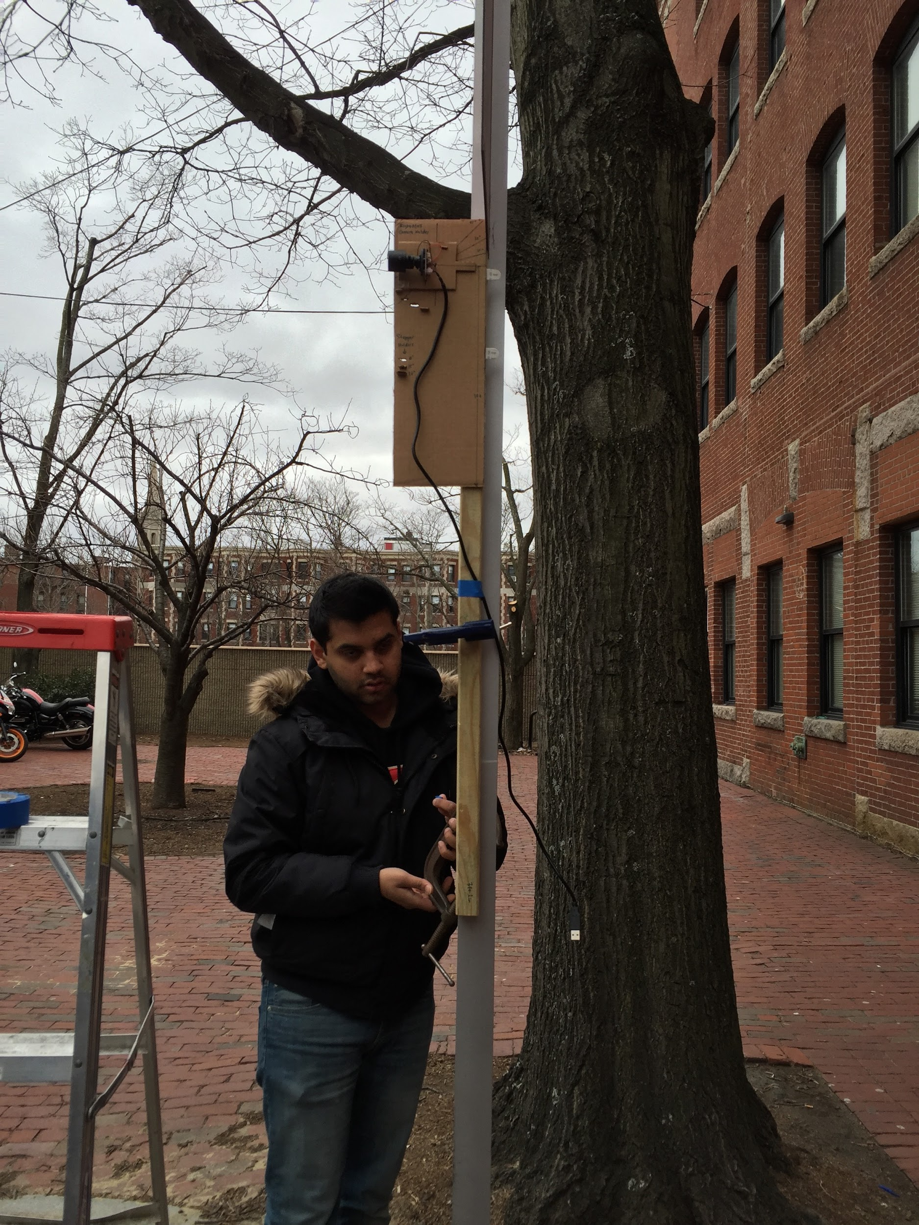

Camera holder on the left and setup of camera on Cummington Mall on right.

To test the best height and angle to mount the camera three variations were implemented. They included having the camera placed 7.5ft high from the ground pointing straight at 0°, 10ft high pointed straight 0°, and 10ft high pointed down 15°. During each setup, 12 pictures were taken, each having one of the team members stand at a multiple of 10ft from the camera. Looking at the pictures we took, we came to conclude that 80ft was the best distance to start detecting a bike. This was because a biker in the frame at 80ft would have enough visible features to train the algorithm and because a biker 80ft from an intersection would give a driver approximately 5.45 seconds to respond to an alert from the sign. The best height and angle for this was 10ft and 0°.

Team members each standing 40ft from camera:

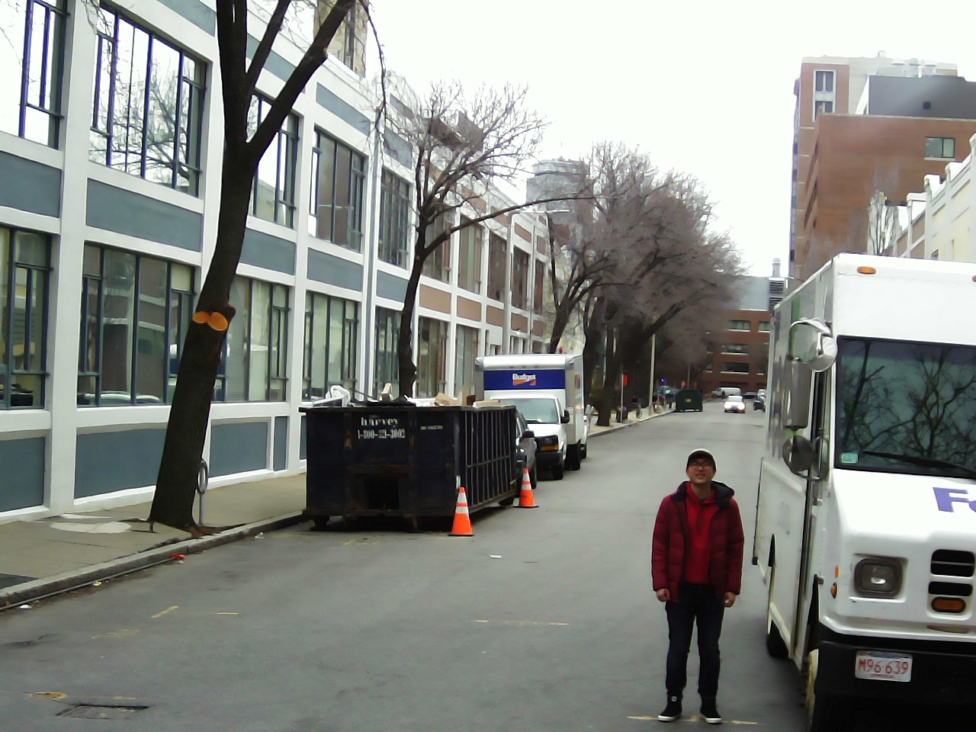 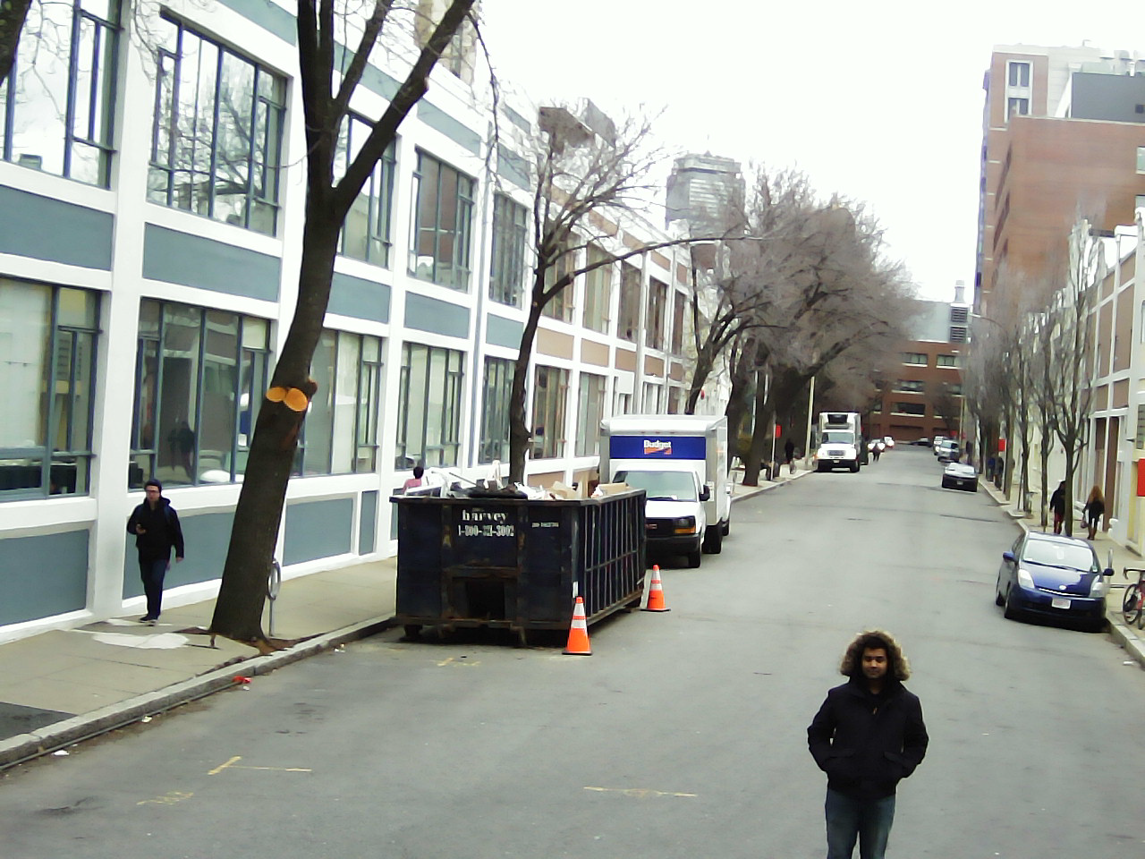

Left picture: camera at 7.5ft pointed 0° Right picture: camera at 10ft pointed 0°

Team Members each standing 80ft from camera:

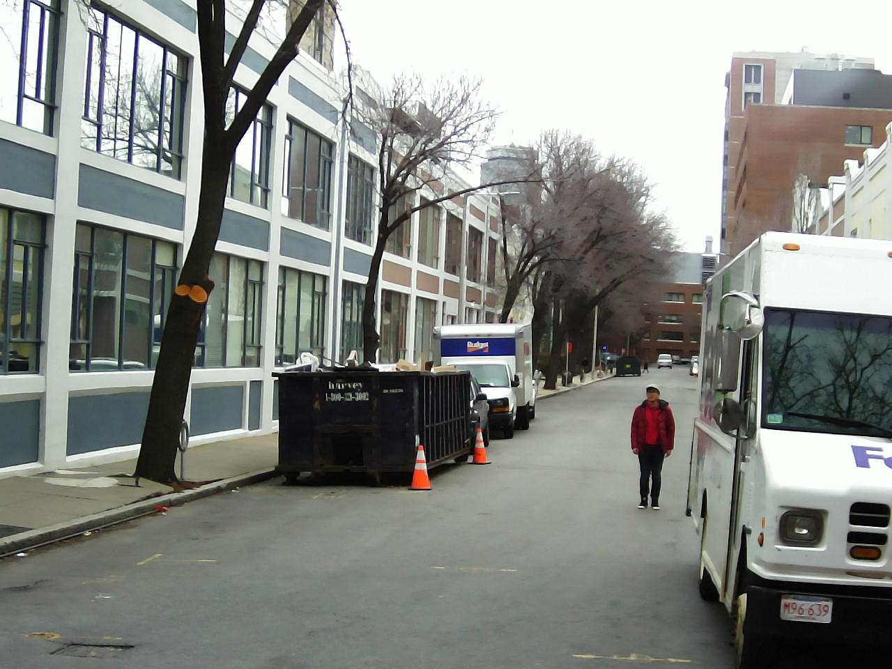 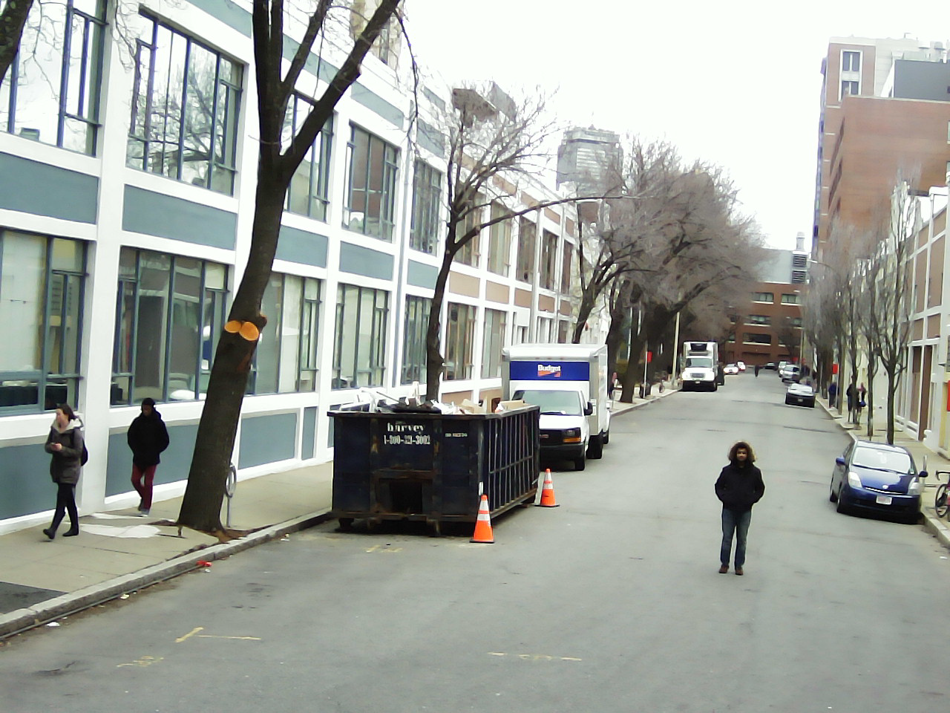

Left picture: camera at 7.5ft pointed 0° Right picture: camera at 10ft pointed 0°

Team member standing 10ft (left) and 30ft (right) from camera

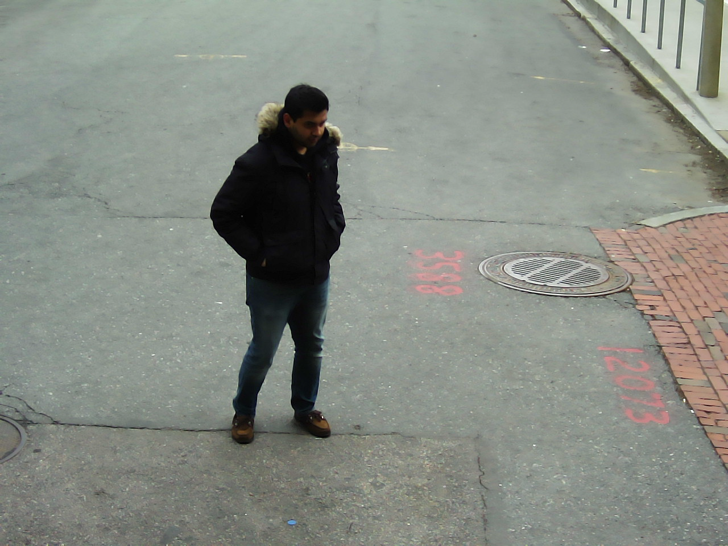 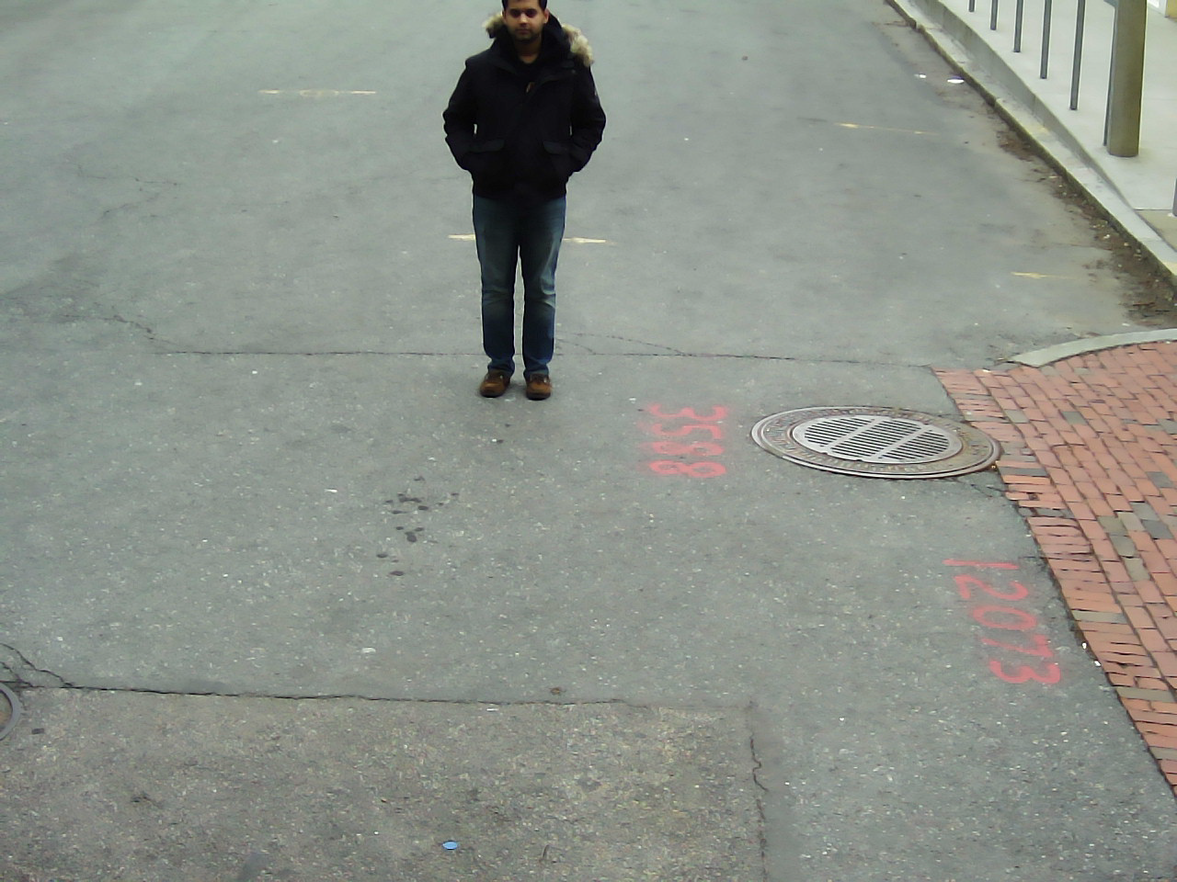

Left and Right picture: camera at 10ft pointed at 15°

After finalizing on the setup of the camera, 2000 pictures were taken of one of our team members on Cummington Mall. These pictures were cropped for both positive and negatives.

Positive Image

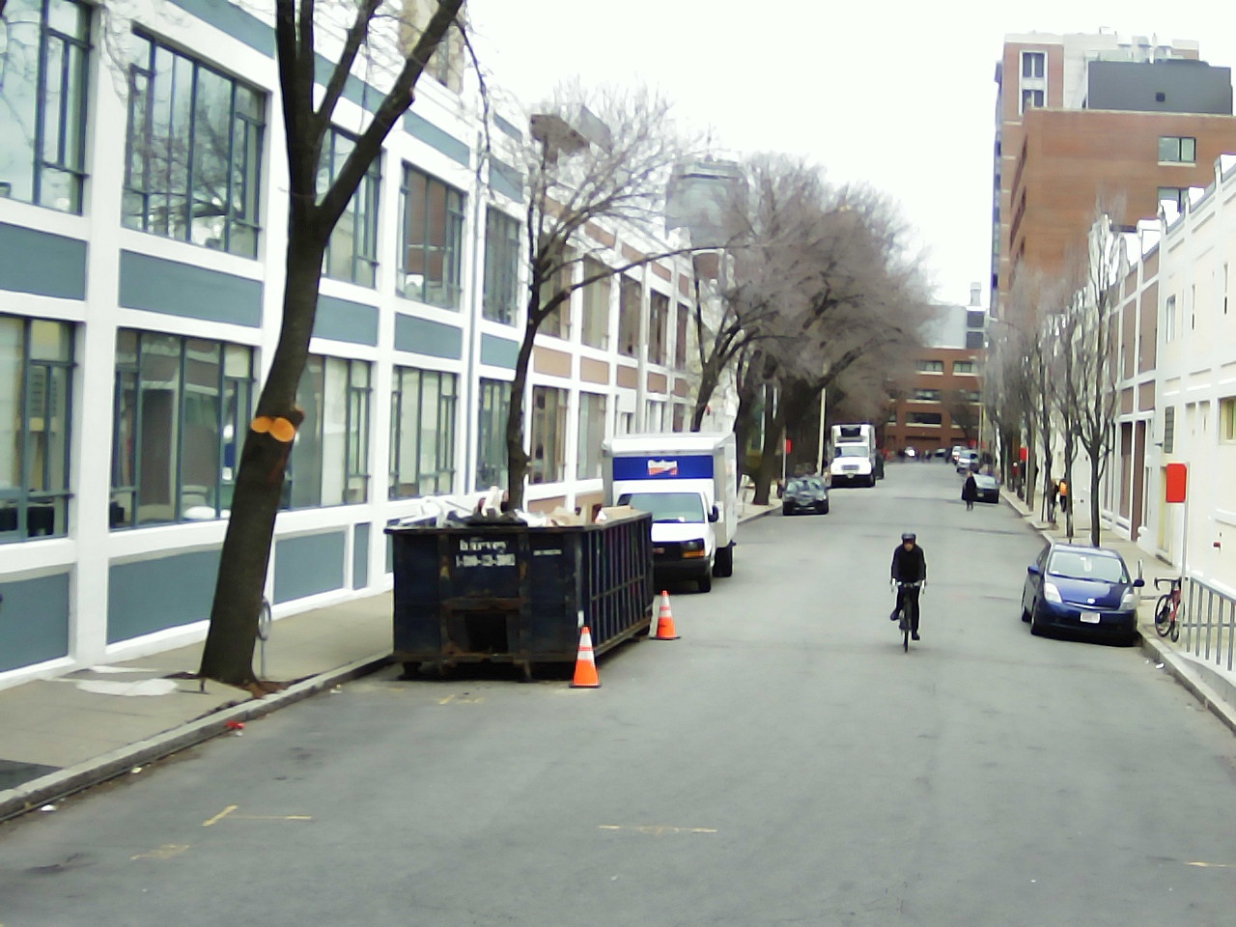 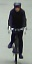

Original picture taken on the left and on the right is the cropped image used for machine learning.

Negative Image

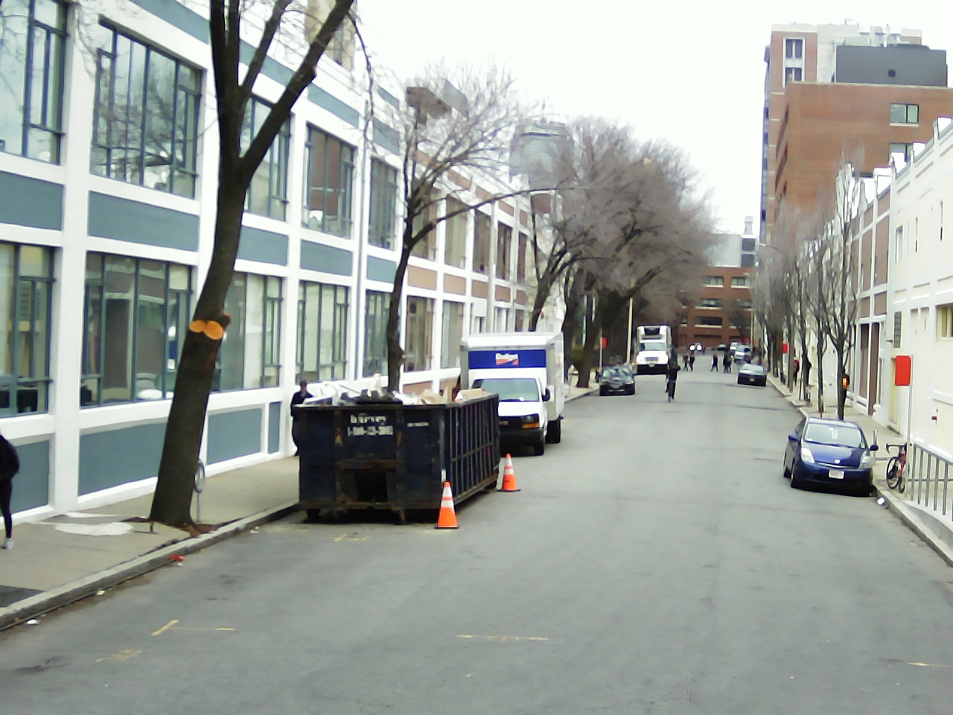 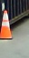

Original picture taken on the left and on the right is the cropped image used for machine learning.

These positive and negatives were then fed into the algorithm’s training process. The video that was tested during the demonstration was also taken with the camera at this height and angle.

**2.0 Bike Detection System**

**2.1 Bike Detection Algorithm**

*Description and Goal*

The bike detection algorithm uses the HOG with SVM approach which is a Machine Learning Algorithm. The procedure trains an SVM classifier with positive and negative training images from the installation site (Cummington Mall). In order to provide an accurate detection rate, training images with rich differences are preferred. The negative images must focus on objects that could look very similar to bikers, eg: people, tree trunks.

Currently, the algorithm has been trained with ~70 positive and ~500 negative training images taken on Cummington Mall. In order to test the performance of this system we tested the predictions of this system for a second dataset we had collected on the same day. The confusion matrix below highlights our results.

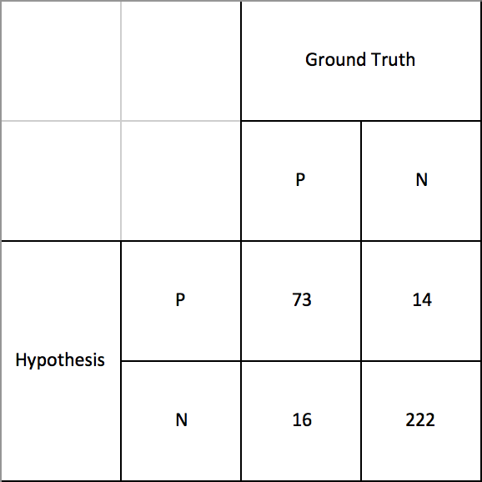

These results yielded a true positive rate of 0.82 and a false positive rate of 0.06. This is a good result for an AI detection system.

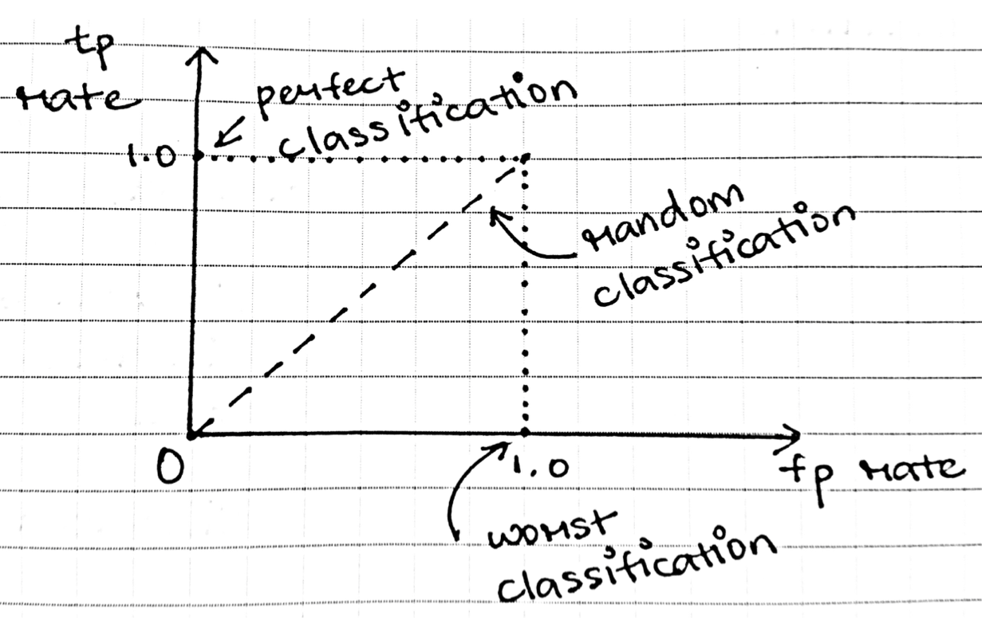

For the demonstration, we plan to run our algorithm on a video of bikers riding down Cummington Mall and observe its accuracy. Afterwards we plan to train the algorithm with an additional set of training images and run the detection algorithm again, expecting to see improvements.

The goal of having a well trained algorithm is to minimize the rate of false negative and false positive readings of oncoming bikers. The lower these rates are, the safer an experience we can guarantee drivers and bikers using an intersection that implements RightAlert.

*Procedure*

To run the algorithm on the test video, first direct yourself to the directory *~/Desktop/Bike\ Detector\ 2.0\ for\ Jetson/2nd\ Deliverable* and run the executable *./hog*.

A GUI window guide the user through the setup.. You will be asked if you would like to train the HOG. We would like to do this in our second iteration, but for now we can skip this step by typing in “no.” Simply follow the rest of the instructions and wait until a window of the video appears.

The program will begin its detection by itself. When a green rectangle is painted around an area of the screen, the algorithm has detected something it believes is a biker. As this is happening, we will be keeping track of the algorithm’s accuracy on a spreadsheet. We will note when a biker has been successfully detected, not been detected at all, or when an object that is not a biker is detected. In addition to this data, we will use the Gnome System Monitor to keep a track of the system’s CPU and memory usage and make note of this to track its efficiency for later improvements. This will continue until the video is over.

The next part of our demonstration requires that we train the algorithm with a new set of positive and negative images. To do so, we rerun the same executable as before and this time select “yes” when asked whether to train the algorithm. The path to the training pictures are already identified in the code so we do not have to do any additional commands at the moment. After waiting for the training to complete, we will follow similar steps as before until we see the video appear in a window again. We will repeat the same procedure recording the accuracy of the detection.

*Verifiable Result*

For the initial test, we will determine a false positive and false negative rate for our bike detection. These values should provide us with assurance that our algorithm will be a safe tool for drivers to use. After the second test, with additional training, we should expect to see even lower false positive and false negative rates.

**2.2 Algorithm Interaction with Alert Sign LEDs**

*Description and Goal*

In order to simulate our custom LED lit alert sign for the demonstration, we substituted a miniature mock-up alert sign with embedded LEDs. The LEDs are connected in parallel in a simple circuit where their positive ends are connected to pin50 of the Jetson and their negative ends are connected the GND on the Jetson. While the detection algorithm is observing the test video, the LEDs will turn on everytime it has made a detection of what it believes is a biker. This test is to ensure the Jetson’s GPIO interact harmoniously with the OpenCV code it is running. This is an incredibly important portion of the alert system because it will be the visual cue drivers will use to stop for oncoming bikers.

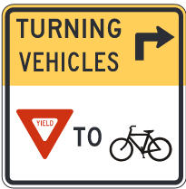 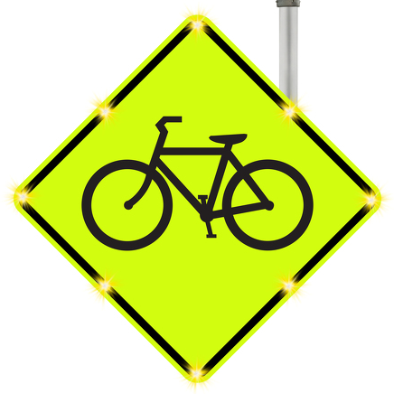

Standard MUTCD sign R10-15 (mod.) Example of TAPCO custom-made sign with 8 LEDs

that we will be using in real system affixed using ultrasonic welding

*Procedure*

Since the LEDs are already connected to the Jetson’s GPIO, we need only to observe them when the algorithm has made a detection. When a biker is detected, we should expect the LEDs to turn on. When a biker is no longer detected the LEDs should turn off.

*Verifiable Result*

We will get desired results if the LEDs turn on the same time a biker is detected in the video and if the turn off when there is no longer a detected biker.

**2.3 Algorithm Interaction with RightAlert Website**

*Description and Goal*

In order to provide daily traffic data on bikers to the public, the alert system will post time-stamps and the number of bikers to the RightAlert website. In order to do so, we have written code to manage this transfer of data from the Jetson to our website. The algorithm, written in C++ also contains C++ code to both turn on the LEDs and update the MySQL database. The RightAlert admin website,<http://admin.rightalert.net> displays a count of how many bikers have been detected by the system. The admin website functions are written with C# using the ASP.NET framework.

*Procedure*

Similar to the LEDs, the algorithm’s update to the RightAlert website should be automatic and rely on no input from the user. We will simply wait for the algorithm to make a detection and observe if a message was received by the website.

*Verifiable Result*

After the algorithm detects a bike, in addition to the LED lights, there is code that updates the MySQL database in the cloud. By visiting<http://rightalert.net/test> or<http://admin.rightalert.net> it can be confirmed that the database was updated with a record of a biker.

**3.0 Right Alert Administration Website**

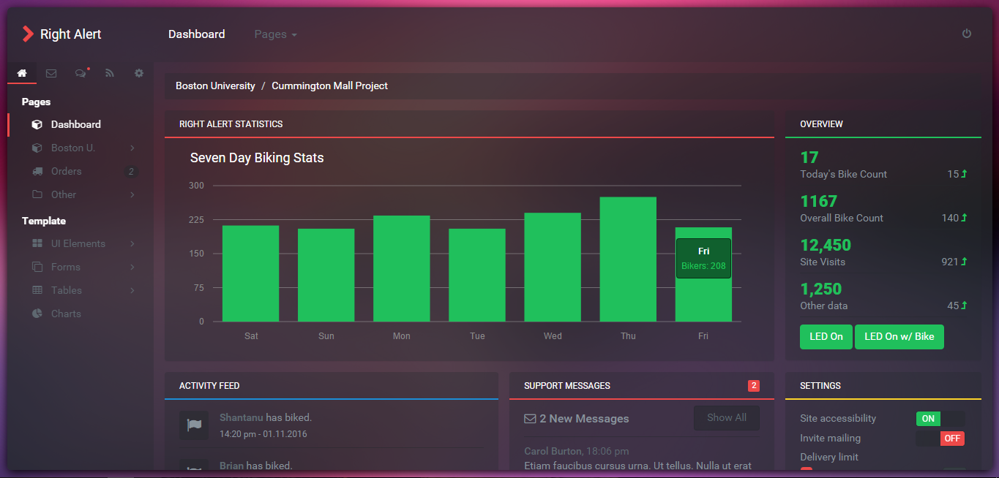

*Description and Goal*

The Right Alert administration website, found at

<http://admin.rightalert.net> allows authorized users to have manual control of the Right Alert system. Right Alert aims to have systems at various intersections therefore an administration portal is necessary for both analysis and management. Authorized users will be provided a centralized web application through which they can view data from and control their Right Alert system(s).

*Procedure*

Currently, the site has two working functions. In this demonstration, we were able to test both the functionality of our MySQL connection to a database and our SSH connection to the NVIDIA Jetson. The connection to the MySQL database is necessary to retrieve and display data to administrators. The SSH connection is used to send manual commands directly the the NVIDIA Jetson which is in control of both the algorithm and the alert sign. In our test, we have two buttons that are being tested. The LED On button and the LED On w/ Bike button. The LED On button tests SSH functionality by making a connection to the Jetson and flashing the alert sign lights. The LED On w/ Bike button extends the previous test with by executing an INSERT statement into the remote MySQL database. When the LED On w/ Bike button click commands finish executing, we also run a MySQL SELECT command to return the number of bikes passed and update the page with that value.

*Verifiable Result*

In the second deliverables test, we were able to successfully show the functionality of the two buttons as well as the labels displaying data. When LED On was clicked, the mock alert sign blinked for approximately 4 seconds, simulating what the final alert sign will do in production. Upon this click we displayed <http://rightalert.net/test> and verified that the database was not changed. Following this, we clicked on the LED On w/ Bike button and again watched the mock alert sign blink. However this time we were able to verify a new entry into the MySQL database on <http://rightalert.net/test>, which displays the MySQL entries from the current date.

**4.0 Conclusion**

**4.1 Algorithm**

The current algorithm does a great job at bike detection, given a sufficient amount of training data and heuristic information. A true positive rate of 0.82 and a false positive rate of 0.06 puts us on a good spot on an ROC curve. However, this is not the end of it. There is scope for improvement and we aim to capitalize on it. One of the current issues is the speed of the detection but this can and will be optimized by using GPU programming.

**4.2 Website**

The website will allow both analysis and control of our final system. When the Right Alert system is mounted on the street, it is preferred to not have to physically touch the device unless hardware maintenance is required. The website will allow us to reboot the device, turn on/off the alert sign, turn on/off detection, etc. Depending on what data we are able to distract from our algorithm, the website will also serve as the portal where data from our system is visualized and analyzed to see our systems reliability and usefulness. Currently, we are working on implementing the graphing features as well as being able to display data real time, possibly using the Microsoft ASP.NET SignalR library.